LINKAGE System

Assurance Test Specification

12/1/2004

Prepared By
Jim Northey, Ravi Vazirani, Ravindra Rade

PREFACE

Scope

This documentation contains the Assurance Test Plan for Linkage components in the CBOEDirect environment. The primary test plan document is the TPF Test Plan. This document should be considered a supplement to that document.

Limitations

This documentation only provides documentation on testing. Operational documentation is provided separately.

References

The following references are provided to support the testing effort

Document Name | Location
TPF Test Plan | documents library project 2042
CBOEdirect operators procedures
Linkage Simulator operators procedures
OCC Operational Readiness Test Plan
OCC Single Exchange Test Plan
OCC Options Linkage Authority Specification
Hub and CBOE Simulator operators document

Table of Contents

1 PREFACE 2
1.1 Scope 2
1.2 Limitations 2
1.3 References 2
2 Overview of Assurance Testing 4
2.1 LINKAGE System Component Under Test 4
2.2 LINKAGE System Test Components 5
3 Test Environments 6
3.1 Hub Simulator Testing Environment 6
3.2 Single Exchange Testing Environment 7
3.3 Multiple Exchange Testing Environment 8
4 Test Protocols 9
4.1 Setup Fixometer 9
4.2 Setup for Single Exchange Testing 9
4.2.1 To Shutdown Linkage System 9
4.2.2 To Start Linkage System 9
4.2.3 To Connect to OCC 9
4.2.4 To Connect to TPF 9
4.3 Setup for Multiple Exchange Testing 10
4.4 Setup for Hub Simulator Testing 10
4.4.1 To Shutdown Linkage System 10
4.4.2 For Startup 10
4.4.3 HubLinkageSimulator commands : 11
4.5 Test Scripts 12
4.6 Linkage Functionality Testing 13
4.6.1 List of test conditions : 13
4.7 High Availability Testing 15
4.7.1 Link failover 15
4.7.2 Server failover 15
4.7.3 High Availability script 15

Overview of Assurance Testing
The Assurance Testing needs to validate three major system components for linkage in the SBT system. There are additional components that are involved in the system.

LINKAGE System Component Under Test
Component Under Test Name | Description
FixLinkageAdapter | Communicates using FIX to the OLA Hub or the OLA Hub Simulator. Communicates using CORBA and the CBOEdirect infrastructure to the Linkage Server.  Contains the Appia 3.2.xx FIX Engine and a new message-handling framework designed to isolate the FIX engine from our application code.
LinkageServer | A version of our trade server that persists linkage messages and sends them to the TpfLinkageAdapter. Communicates using CORBA and the CBOEdirect infrastructure.
TpfLinkageAdapter | A version of the TpfAdapter that communicates to TPF using the ApplAppl communication protocol. Communicates with the LinkageServer using CORBA and the CBOEdirect infrastructure.

Testing Component Name | Description
Hub Simulator  a.k.a OLA Hub Simulator | A CBOE simulator that uses a new simulator framework. The Hub Simulator simulators the OLA Hub and the away exchanges. The OLA Hub can be used to generate messages and to respond to messages. The OLA Hub Simulator is controlled using a combination of a Web interface and when a script is running a command line interface.
CBOE Simulator | Simulates the behavior of the CBOE linkage system. Can be used to send messages to the OLA Hub or the OLA Hub Simulator and to respond to messages received from the OLA Hub and OLA Hub Simulator. The operation of the CBOE Simulator is similar to the operation of the Hub Simulator.

LINKAGE System Test Components
Testing is performed by using a FIX Firm simulator that is composed of a test driver program and an Appia FIX engine. The test driver reads a script file, sending and receiving FIX messages. The Firm Simulator – will display messages from the script file that describes each test. The simulator is used to send FIX messages to LINKAGE. The simulator receives FIX response messages from the LINKAGE for these requests. The Firm Simulator supports the following types of commands:

#msg – display a message to the console
# comment
#int – Interrupt processing and wait for the test operator to press “C” for continue.

All other lines in the file are interpreted as raw FIX messages that are read and sent to the FIX engine.

Test Environments

Hub Simulator Testing Environment
This environment is run here at CBOE using CBOE developed testing tools. The system must be configured to use the OLA Hub Simulator. The OLA Hub Simulator acts like the OCC Hub and one or more Away Exchanges. The OLA Hub Simulator can be configured to respond to outbound linkage orders by exchange and symbol. It can also be configured to inject linkage order flow from away exchanges. The OLA Hub Simulator is controlled by Administrative Requests and a Web browser interface.
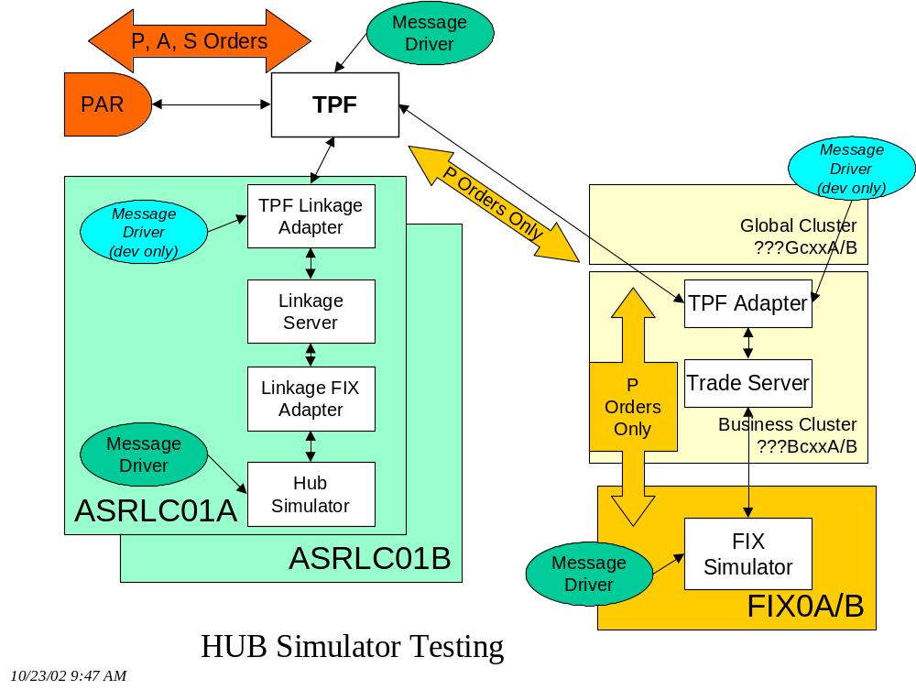
The Hub Simulator operator’s procedures define how to use the Hub Simulator.

Single Exchange Testing Environment
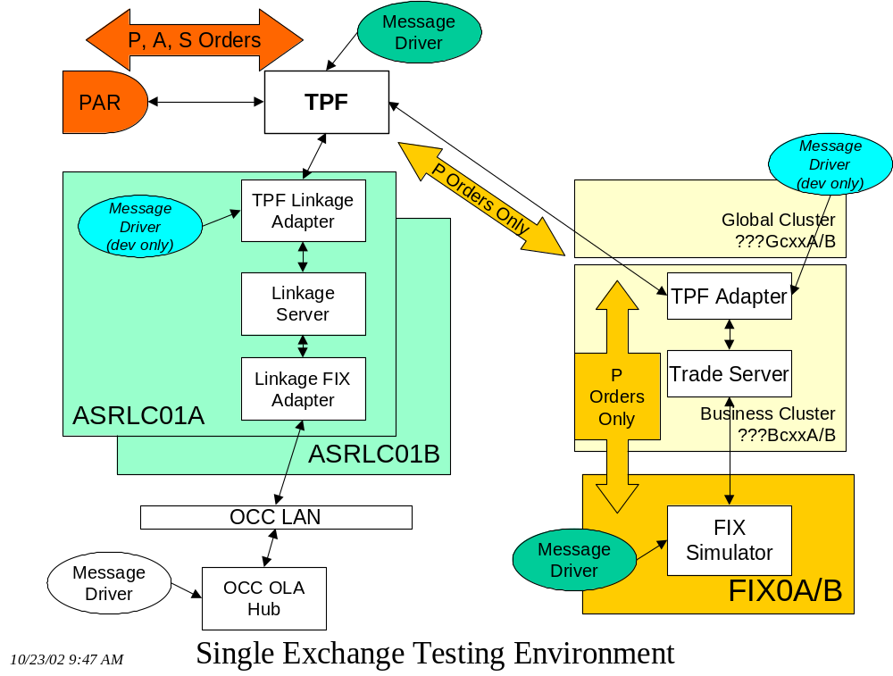
The Single Exchange Testing environment is connected to the OCC LAN and the OCC Hub. OCC provides a simulator to respond to messages destined for away exchanges and to inject linkage orders from away exchanges. The use of this test environment is scheduled by the OCC.

Multiple Exchange Testing Environment
The Multiple Exchange Testing Environment is connected to the OCC Hub. Instead of a simulator - there are multiple exchanges connected live for testing. Multiple Exchange testing is scheduled by the OCC.
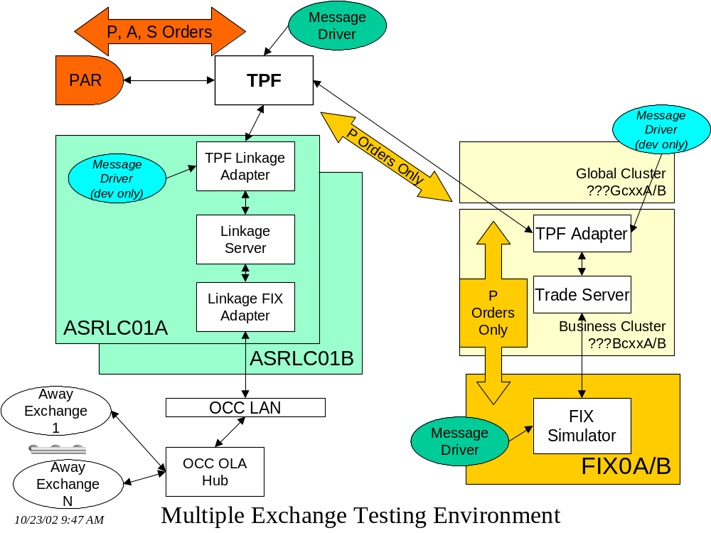

Test Protocols
The following Test Protocols are to be executed.
- Start LINKAGE environment
- Linkage Functionality Testing
- High Availability Test (highAvailability.script).

NOTE:
Throughout this document we will assume that asrlc01a is the primary box and asrlc01b is the backup box.

Setup Fixometer
The Fixometer can be brought up by running the following bat file from windows desktop.
\\corp\sys\shared\cboe_fix\linkage\fixometer\ascrlc01_tradenga\startFixometer.bat

Setup for Single Exchange Testing
If you don’t want to preserve the state information from the previous run (like the sequence numbers between OCC and Linkage System), then , shutdown the Linkage system , perform cleanup and then restart the system.

If you do want to preserve the state information then just restart the system.

To Shutdown Linkage System
- Login to asrlc01b using the appropriate login
- Run the command stopTradeengSystem LC Slave
- Login to asrlc01a using the appropriate login
- Run the command stopTradeengSystem LC Master
- On both asrlc01a and asrlc01b run the command cleanupServer -noAsk.

To Start Linkage System
- Use the Linkage operator procedures to start the linkage system.
- Short list of procedures is
- Login on asrlc01a using the appropriate login.
- Run startTradeengSystem LC Master
- Login on asrlc01b using the appropriate login
- Run startTradeengSystem LC Slave

To Connect to OCC
- Use the fixometer to connect the fix linkage adapter to OCC.

To Connect to TPF
- On the asrlc01a box run the command linkageExternalServices start
- Run the command linkageExternalServices check to verify connectivity to TPF.

Setup for Multiple Exchange Testing
This setup is same as the Single Exchange Test setup.
Representatives from all exchanges need to get together to figure out what classes to use and what type of messages will be tested.

Setup for Hub Simulator Testing
Following is short list of instructions on how to start the linkage system in simulator mode.

If you don’t want to preserve the state information from the previous run (like the sequence numbers between HUB Simulator and Linkage System), then , shutdown the Linkage system and perform cleanup , then restart the system.
If you do want to preserve the state information then just restart the system.

To Shutdown Linkage System
- Login to asrlc01b using the appropriate login
- Run the command stopTradeengSystem LC Slave
- Login to asrlc01a using the appropriate login
- Run the command stopTradeengSystem LC Master
- On both asrlc01a and asrlc01b run the command cleanupServer -noAsk.

For Startup
On asrlc01a run the following commands
- startServer -m fixLinkageSim - To start Fix linkage adapter so it connects to the Hub Simulator
- startServer -m hubLinkageSim - Background mode for testing outbound orders only
OR
Open new window and run
startServer -mf hubLinkageSim - Foreground mode for testing inbound and outbound
testing
- startServer –m –n 1 linkageServer – To bring up the linkage server.
- startServer –m tpfLinkageAdapter – To bring up the tpf linkage adapter.
- ar TpfLinkageAdapter startAllServices – To enable connections to TPF
- Use the FIXOMETER – To connect and disconnect the FixLinkageSim to/from the HUB Simulator.

On asrlc01b run the following commands
- startServer fixLinkageSim – To start FixLinkageSim in slave mode
- startServer –n 1 linkageServer – To start the linkage server in slave mode.
- startServer tpfLinkageAdapter - To start TpfLinkageAdapter in slave mode.

NOTE: The Fixometer can be brought up by running following the bat file from windows desktop.
\\corp\sys\shared\cboe_fix\linkage\fixometer\ascrlc01_tradenga\startFixometer.bat

HubLinkageSimulator commands :

For testing Only Outbound orders :

1. on asrlc01a , from $RUN_DIR, perform startup as stated above.

This will start the linkage system connected to the HUB simulator. HUB Simulator can be set up to respond to outbound orders.

There are some default settings like, if order is sent using class IBM, it will always get filled (unless simulator setup is changed).

To see which products will get filled if sent to away exchange ASE (AMEX), run,
ar HubLinkageSim getPropertyValue ASE ProductsToBeFilled
OR
ar HubLinkageSim getPropertyValue ASE ProductsToBePartiallyFilled

To remove products to be filled, run,
ar HubLinkageSim removePropertyValue ASE ProductsToBeFilled IBM

To add products to be filled, run,
ar HubLinkageSim addPropertyValue ASE ProductsToBeFilled IBM

It is recommanded that to check if properties are set properly by using getPropertyValue command after addPropertyValue command.

To see what other commands are available execute the following command
ar HubLinkageSim help

Acronyms for exchanges :
CBOE : CBO Philadelphia : PHO
AMEX : ASE Pacific : PSE
Philadelphia : PHO ISE : ISX

Please refer to the Linkage System operators procedures for complete list of possible
setup for HubLinkageSimulator.

For testing Outbound and Inbound orders :

- Perform startup as above.
- Bring down HubLinkageSim if it is running in background mode, we need to restart it in foreground mode by entering command , kill pid - where pid is process id of HubLinkageSim From $RUN_DIR, to get pid run chk
- Open new second window and run : startServer -mf hubLinkageSim. Keep this window open.
- From first window, modify the scripts/p.order script as needed. (See detail on how to modify the script below)
- From first window, cd $RUN_DIR , run :
ar HubLinkageSim startSimulationService scripts/p.order
- Go to second window where HubLinkageSim is running in foreground mode , type c to continue.
- To make sure the scripts are ok, check communication between fixLinkageSimulator and hubLinkageSimulator using CMC viewer GUI or open new window and use command,
showFixLog fixLinkageSim –wait –exclude 35=0
- To check communication between linkage system and tpf, check TpfLinkageAdaper.debug file by entering command : tail –f TpfLinkageAdaper.debug
- To check if linkageSystem is connected to TPF : connectionStatus TpfLinkageAdapter
- If not connected, to connect to TPF , run, : ar TpfLinkageAdapter startAllServices

Test Scripts

There are several script files, for several test conditions (listed in section 4.3)
/vobs/dte/linkage/testScripts folder. New scripts can be created by copying and
modifying the scripts. Example using p.order script is illustrated here.

Script | Description
p.order | To test inbound P order
s.order | To test inbound S order
pa.order | To test inbound P/A order
pa.cancel | To test pa order followed by cancel request
s.cancel | To test S order followed by cancel request
Ola_acceptance_test.script | This test script was generated from the FIX messages sent from the OLA Hub to CBOE during acceptance testing. The messages sent using this script are identical to the messages sent by OLA
Ola_single_exchange_test.script | To run the single exchange OCC test plan.
Test.script | For testing as per use cases and test cases.
logonLogoff.script | To run log on and log off tests

Edit p.order script using VI editor.
Change the values of following fix tags as per requirement.
Other tag values can also be changed as needed.
Following is the list of tags which are most frequently changed.
These changes are required to make sure we get proper responses from TPF like fill,
partial fill, cancel etc.

Fix Tag | Description | Valid values
55 | Symbol | Valid symbol
202 | Strike Price
200 | Series (Product)
201 | Option Type | 0 = PUT , 1= CALL
54 | Side | 1=BUY, 2 = SELL
44 | Price
38 | Volume

Special editing needed for pa.cancel and s.cancel scripts.
- Change the fix tags as per requirement listed in above table.
- This script consists of an order followed by cancel request.
- Change value of tag 11 for order and tag 41 for cancel request to next value (increment by 1). This is required because order id needs to be unique during the day.
- This increment needs to done each time before running the script.

The startup for the day consists of the following tests:
Synchronizing the time of the TPF environment with the asrlc01a host. asrlc01a is synchronized with NIST time - it is within 2 seconds of the time of the OLA Hub at OCC.

Linkage Functionality Testing

List of test conditions :

Test Case | Test Script | Tested | Notes
INBOUND - P ORDERS
Inbound P orders – Filled | p.order
Inbound P orders - Partially Filled | p.order
Inbound P orders – Fill when market size less then FPQS
Inbound P orders - Canceled following Partial Fill | p.order
Inbound P orders - Rejected | p.order
Inbound P orders - Timeout cancel report | p.order
OUTBOUND - P ORDERS
Outbound P orders – Filled | Not needed
Outbound P orders - Partially Filled | Not needed
Outbound P orders - Canceled following Partial Fill | Not needed
Outbound P orders - Rejected | Not needed
INBOUND – P/A ORDERS
Inbound P/A orders – Filled | pa.order
Inbound P/A orders - Partially Filled | pa.order
Inbound P/A orders – Fill when market size less then FCQS | pa.order
Inbound P/A orders - Canceled following Partial Fill | pa.order
Inbound P/A orders - Rejected | pa.order
Inbound P/A orders - Cancel Request with Cancel response from TPF | pa.cancel
Inbound P/A orders - Cancel Request with Cancel Reject response from TPF | pa.order
Inbound P/A orders - Timeout cancel report from TPF | pa.order
OUTBOUND P/A ORDERS
Outbound P/A orders – Filled | Not needed
Outbound P/A orders - Partially Filled | Not needed
Outbound P/A orders - Canceled following Partial Fill | Not needed
Outbound P/A orders - Rejected | Not needed
Outbound P/A orders - Cancel Request with Cancel response from Linkage | Not needed
Outbound P/A orders - Cancel Request with Cancel Reject response from linkage | Not needed

Test Case | Test Script | Tested | Notes
INBOUND – S ORDERS
Inbound S orders – Filled | s.order
Inbound S orders - Partially Filled | s.order
Inbound S orders - Canceled following Partial Fill | s.order
Inbound S orders - Rejected | s.order
Inbound S orders - Cancel Request with Cancel response from TPF | s.cancel
Inbound S orders - Cancel Request with Cancel Reject response from TPF | s.cancel
Inbound S orders – Fill with Agents order | s.order
Inbound S orders – Fill with Crowd | s.order
Inbound S orders – Fill with cancel remaining | s.order
Inbound S orders – Fill DK’d from Linkage | s.order
OUTBOUND – S ORDERS
Outbound S orders – Filled | Not needed
Outbound S orders - Partially Filled | Not needed
Outbound S orders – Canceled following Partial Fill | Not needed
Outbound S orders - Rejected | Not needed
Outbound S orders – Reject the fill | Not needed
Outbound S orders - Cancel Request with Cancel response from Linkage | Not needed
Outbound S orders - Cancel Request with Cancel Reject response from Linkage | Not needed
CBOEDirect Testing (as TpfAdapter code base is same)
Few trades from GUI on W_MAIN | Not needed
Few trades from GUI on ONE_MAIN | Not needed
Send Order From TPF for W_MAIN from TPF and Fill on CboeDirect GUI | Not needed
Send Order to TPF for W_MAIN and have TPF fill the order - Verify fill on CboeDirect | Not needed
P Order testing from CBOEDirect firms (will need FIX 4.2 support to enter these orders and verify)
Send P order from Fix4.2 to linkage. | Not needed
Fill P order (Check if Fix4.2 Receives Fill report) | Not needed
Partially fill order (Check if Fix4.2 receives Partial Fill and Cancel report) | Not needed

High Availability Testing

Link failover
- Disconnect primary connection to OCC.
- Use Fixometer to re-connect and make sure connection fails over to backup connection.

Server failover
- On the primary lc box run the command stopTradeengSystem LC Master.
- On the Secondary lc box run the command
switchTradeengSystem LC goMaster.
- Run the command linkageExternalServices start to enable connections to TPF.
- Run the command linkageExternalServices check to verify if all the connections to TPF have been established.
- Use the Fixometer to connect to OCC or the Hub Simulator
- Verify that OCC connectivity is OK using the FIXOMETER.
- Send Inbound and outbound ,orders and execution reports to verify that all message flow occurs as normal and that no messages are lost or resubmitted after the failover.

High Availability script
- Run thru the highAvailablity.script . The script will guide you through the process of running different test cases..

